Hackathon Project Phases Template for the AutoSage App project.

Hackathon Project Phases Template
Project Title:
GEMINI PRO FINANICAL DECODER
Team Name:
Analyst Hacker
Team Members:
- T.TEJA
- T.PAVAN SAI
- SD.RAZAK
- T.MAHESH
- S.PUNNARAO

Phase-1: Brainstorming & Ideation
Objective:
The objective of Gemini Pro Financial Decoder is to provide advanced financial analysis, enabling accurate predictions, investment insights, and data-driven decision-making to optimize wealth management and enhance portfolio performance.
Key Points:
- Problem Statement:
1.Challenge: Investors face difficulty in analyzing large volumes of financial data, identifying trends, and making accurate predictions in a volatile market.

.
- Proposed Solution:
Solution: Gemini Pro Financial Decoder aims to simplify financial analysis and improve decision-making for optimized investment outcomes and portfolio performance

- Target Users:

Individual Investors & Financial Professionals: Those seeking accurate insights for informed decision-making and portfolio optimization.
Institutional Investors & Trading Firms: Organizations requiring advanced tools for data analysis, market forecasting, and efficient risk management.
.
- Expected Outcome:
Improved Decision-Making: Users can make data-driven, informed investment choices with accurate market predictions and trend analysis.
Enhanced Portfolio Performance: Optimized investment strategies and risk management lead to better returns and minimized risks for users.

  - .

Phase-2: Requirement Analysis
Objective:
Requirement Analysis is to gather and define the specific needs, expectations, and functionalities required by users and stakeholders. This phase aims to ensure a clear understanding of the project scope, technical requirements, and desired outcomes, setting the foundation for designing and developing the Gemini Pro Financial Decoder effectively.
Key Points:
- Technical Requirements:
- Data Integration: Connect with financial data sources for real-time analysis.
- User Interface: Simple, intuitive design for easy access to tools and reports.
- Security: Strong protection for sensitive financial data.
- Scalability: Ability to handle increased data and users.
- AI/ML Features: Utilize AI/ML for accurate market predictions.

- Functional Requirements:
- Real-Time Market Analysis: Ability to analyze and display live market data and trends.
- Predictive Analytics: Provide forecasts and investment recommendations based on historical data and algorithms.
- Portfolio Management: Track, manage, and optimize user investment portfolios.
- Custom Alerts: Set notifications for market changes, price fluctuations, or portfolio performance.
- Reporting: Generate detailed financial reports and insights for decision-making.

- Constraints & Challenges:
- Data Accuracy: Ensuring the quality and reliability of financial data for accurate analysis and predictions.
- System Performance: Handling large volumes of real-time data without lag or performance issues.
- Security: Safeguarding sensitive financial information from cyber threats and breaches.
- Integration Compatibility: Seamless integration with various data sources and third-party platforms.
- User Adaptability: Ensuring the platform is easy to use for both novice and experienced investors.
- Regulatory Compliance: Adhering to financial regulations and data privacy laws in different regions.

Phase-3: Project Design
Objective:
Project Design is to create a detailed plan outlining the system architecture, user interface, and technical framework, ensuring scalability, security, and alignment with user needs for development.
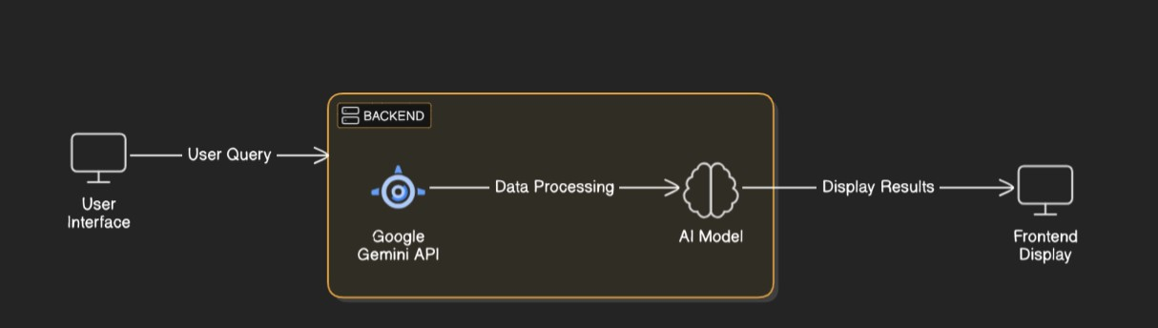
Key Points:
Here’s the modified version based on your project idea:

1. System Architecture:
- User enters financial-related query via UI (e.g., "Best investment opportunities in stocks").
- Query is processed using the Gemini Pro Financial Decoder API.
- AI model analyzes market data and trends.
- Frontend displays financial insights, predictions, and portfolio recommendations.
2. User Flow:
- Step 1: User enters a financial query (e.g., "Top performing stocks for Q1 2025").
- Step 2: Backend calls the Gemini Pro API to retrieve real-time market data and analysis.
- Step 3: The app processes the data and presents insights, forecasts, and investment suggestions in a user-friendly format.
3. UI/UX Considerations:
- Clean, intuitive interface for easy navigation through financial tools and reports.
- Filters for data types like stocks, bonds, or commodities, as well as performance metrics.
- Dark & light mode for customizable viewing preferences.

.

Phase-4: Project Planning (Agile Methodologies)
Objective:
Break down development tasks for efficient completion.
Sprint | Task | Priority | Duration | Deadline | Assigned To | Dependencies | Expected  Outcome
Sprint 1 | Environment Setup&API Integration | 🔴 High | 6 hours  (Day 1) | End of Day  1 | Member 1 | Financial data APIs, Python setup | API connection established & working
Sprint 1 | Frontend UI Development | 🟡  Medium | 2 hours  (Day 1) | End of Day  1 | Member 2 | API response format finalized | Basic UI with input fields
Sprint 2 | Data Processing & Financial Analysis | 🔴 High | 3 hours  (Day 2) | Mid-Day 2 | Member 1& 2 | API response, data processing tools | Search functionality with filters
Sprint 2 | Error Handling & Debugging | 🔴 High | 1.5 hours  (Day 2) | Mid-Day 2 | Member 1&4 | API logs, UI inputs | Improved API stability
Sprint 3 | Testing & UI Enhancements | 🟡  Medium | 1.5 hours  (Day 2) | Mid-Day 2 | Member 2& 3 | API response, UI layout completed | Responsive UI, better user experience
Sprint 3 | Final Presentation & Deployment | 🟢 Low | 1 hour  (Day 2) | End of Day  2 | Entire Team | Working prototype | Demo-ready project
Sprint 1 – Setup & Integration (Day 1)
- (🔴 High Priority) Set up the development environment and install dependencies.
- (🔴 High Priority) Integrate Google Gemini API and ensure it connects successfully.
- (🟡 Medium Priority) Build a basic UI with input fields for user interaction.
Sprint 2 – Core Features & Debugging (Day 2)
- (🔴 High Priority) Implement search and comparison functionalities for financial data.
- (🔴 High Priority) Debug API issues and handle errors in queries.
Sprint 3 – Testing & Deployment (Day 2)
- (🟡 Medium Priority) Test API responses, refine UI, and fix bugs.
- (🟢 Low Priority) Finalize demo preparation and deploy the project.

Phase-5: Project Development
Objective:
Implement core features of the Gemini Pro Financial Decoder to analyze and compare financial data efficiently.
Key Points:
- Technology Stack Used:
  - Frontend: Streamlit
  - Backend: Google Gemini API
  - Programming Language: Python
- Development Process:
  - Implement API key authentication and integrate Google Gemini API for financial data retrieval.
  - Develop financial analysis and comparison logic to evaluate market trends and investment opportunities.
  - Optimize search queries for speed and accuracy in fetching relevant financial data.
- Challenges & Fixes:
  - Challenge: Slow API response times.
    - Fix: Implement caching to store frequently accessed financial data.
  - Challenge: Limited API request quota.
    - Fix: Optimize queries to fetch only necessary financial information efficiently.

Phase-6: Functional & Performance Testing
Objective:
Ensure that the AutoSage App works as expected.
Test Case ID | Category | Test Scenario | Expected Outcome | Status | Tester
TC-001 | Functional  Testing | Query "Top performing stocks under $50" | Relevant stock data should be displayed.. | ✅ Passed | Tester 1
TC-002 | Functional  Testing | Query "Best investment options for 2025 | Seasonal tips should be provided. | ✅ Passed | Tester 2
TC-003 | Performance  Testing | API response time under 500ms | API should return results quickly. | ⚠ Needs Optimization | Tester 3
TC-004 | Bug Fixes & Improvements | Fixed incorrect API financial predictions. | Data accuracy should be improved. | ✅ Fixed | Develop er
TC-005 | Final Validation | Ensure UI is responsive across devices.. | UI should work on mobile & desktop. | ❌ Failed - UI broken on mobile | Tester 2
TC-006 | Deployment  Testing | Host the app using cloud deployment. | App should be accessible online. | 🚀 Deployed | DevOps

Final Submission
- Project Report Based on the templates
- Demo Video (3-5 Minutes)
- GitHub/Code Repository Link
- Presentation

